NATIONAL UNIVERSITY OF SCIENCES & TECHNOLOGY
School of Electrical Engineering & Computer Science (SEECS)
Parallel and Distributed Processing | HPC Project
HPC Setup & Execution
Laplace Solver
Course | Parallel and Distributed Processing
Submitted by | Awais Asghar
Instructor | Dr. Attique Dawood
HPC System | NUST RCMS Supercomputer
Compute Node | compute-0-5
Date | May 2026

Overview
This document is a complete guide covering every single step required to log in, upload, compile, run, and verify the Laplace Solver project on the NUST RCMS HPC Supercomputer. Every command is written exactly as it should be typed. Nothing is skipped.

What you need | PC with WSL (Ubuntu) or a Linux machine
HPC username | awais.seecs (replace with your own username)
HPC IP address | 10.19.10.50
Head node name | afrit
Compute node used | compute-0-5
Project folder | C:\Users\DELL\OneDrive - National University of Sciences & Technology\NUST\8th Semester\Parallel and Distributed Processing\Lab Work\Project\Solution\Project
Offline nodes | compute-0-7, 14, 15, 20, 25, 29, 30 (do not use)
WARNING: Never run simulations on the head node (afrit). Always SSH into a compute node first. Any simulation on the head node will be terminated without warning and data may be lost.

Phase 1: Uploading the Project to HPC

1.1 Open Your Terminal
Open WSL (Windows Subsystem for Linux) on your Windows PC in the Project Folder, or a Linux terminal on a Linux machine. All commands in this document are typed in this terminal window.



1.2 Upload the Project Folder to HPC
Run this one command. There are 2 commands for temporary users use scp and for your own username use 2nd command.

scp -r -O -oHostKeyAlgorithms=ssh-rsa Project user2@10.19.10.50:~

rsync -avz --progress -e "ssh -p 22 -oHostKeyAlgorithms=+ssh-rsa" . awais.seecs@10.19.10.150:~/Solution

Enter your HPC password when prompted. You will see each file uploading with progress percentages:
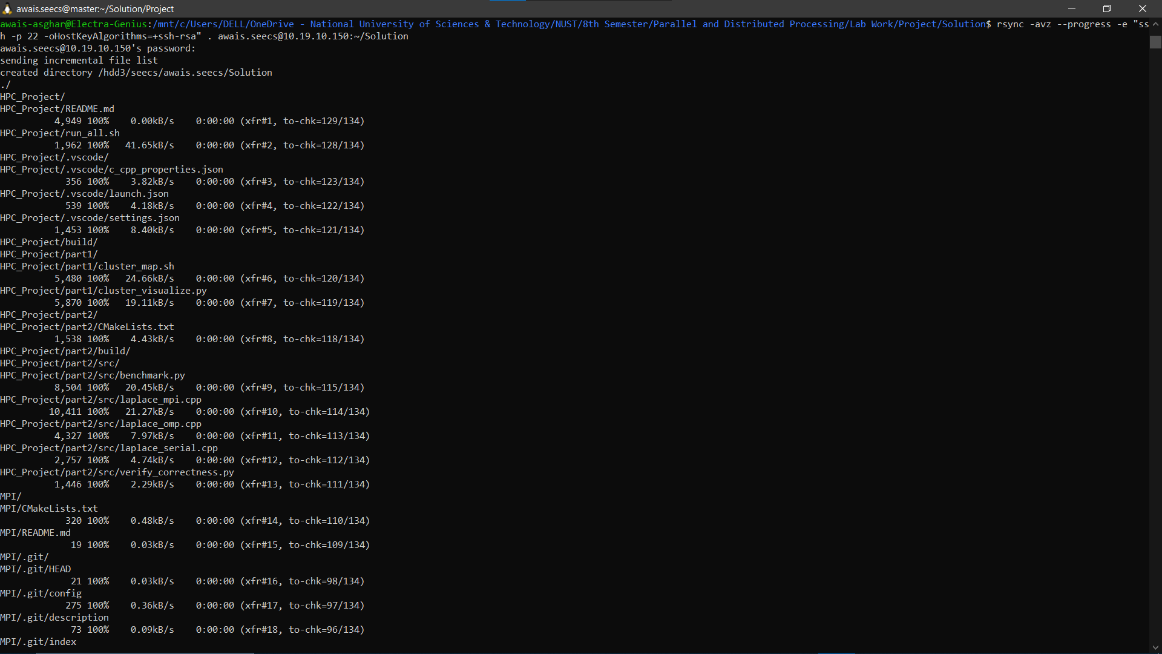

Phase 2: Again Logging Into the HPC

2.1 SSH Into the HPC Head Node
Type one of these commands according to your user type exactly to connect to the HPC. Confirm the content in your HPC using ls.

ssh -X user2@10.19.10.50 -oHostKeyAlgorithms=+ssh-rsa

ls

ssh -X awais.seecs@10.19.10.150 -p 22 -oHostKeyAlgorithms=+ssh-rsa

ls

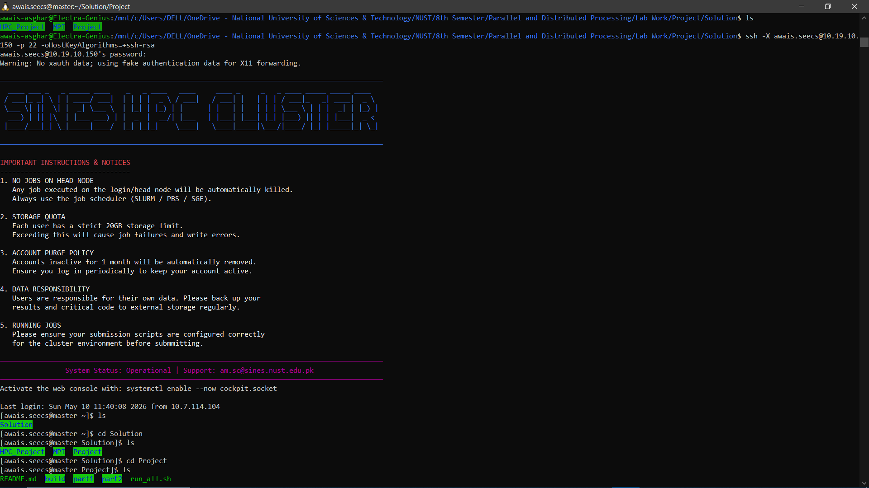

2.2 Navigate to the Build Folder

cd Solution
ls

cd Project
ls

cd part2
ls

cd build
ls

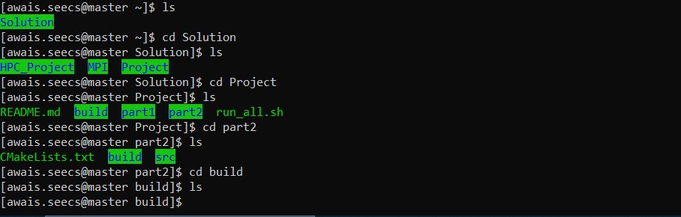

2.3 Build the project using cmake

cmake ..

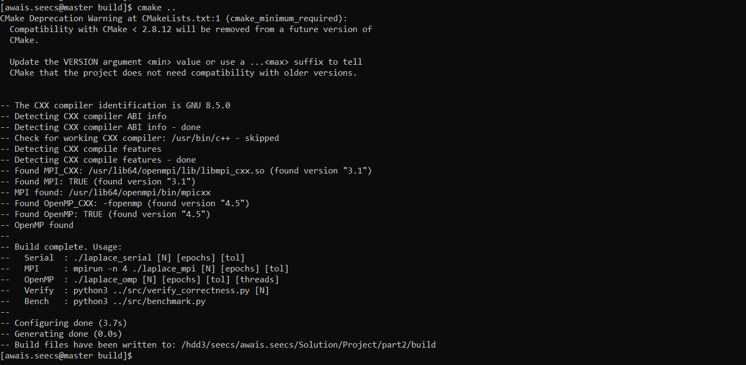

2.4 Compile All Three Solvers
make -j4

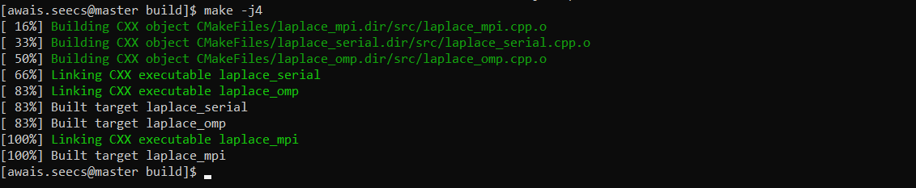

2.5 Verify Binaries Were Created
ls

Phase 3: Setting Up the Results Folder

3.1 Create the Results Directory

mkdir -p ~/Project/part2/results

3.2 Copy Binaries and Scripts Into Results
Copy all compiled binaries and Python scripts into the results folder so everything is available in one place on the compute node:

cp ./laplace_mpi ~/Project/part2/results/
cp ./laplace_omp ~/Project/part2/results/
cp ./laplace_serial ~/Project/part2/results/
cp ../src/verify_correctness.py ~/Project/part2/results/

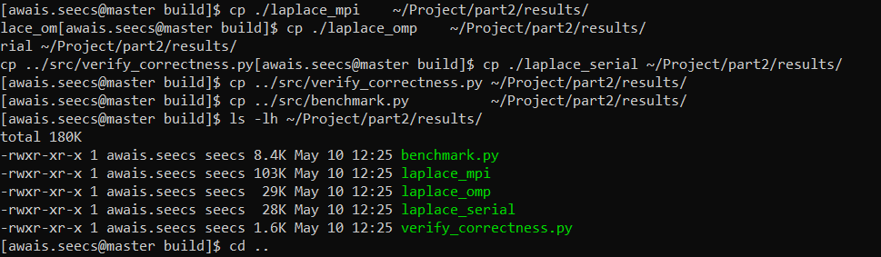

3.3 Confirm Everything Is in Place

cd ..
ls -lh ~/Project/part2/results/



3.4 SSH Into the Compute Node

Go to result folder and check the that files (benchmark.py laplace_mpi laplace_omp laplace_serial verify_correctness.py ) are visible or not. Then run the serial solver and MPI solver with 4 processes. Run the OpenMP solver using with 4 threads and run the verification script. Please check the python version on your HPC. In my case, I have a python3.

cd ~/Project/part2/results
./laplace_serial 32 10000 1e-4
mpirun -n 4 ./laplace_mpi 32 10000 1e-4
./laplace_omp 32 10000 1e-4 4
python3 verify_correctness.py 32

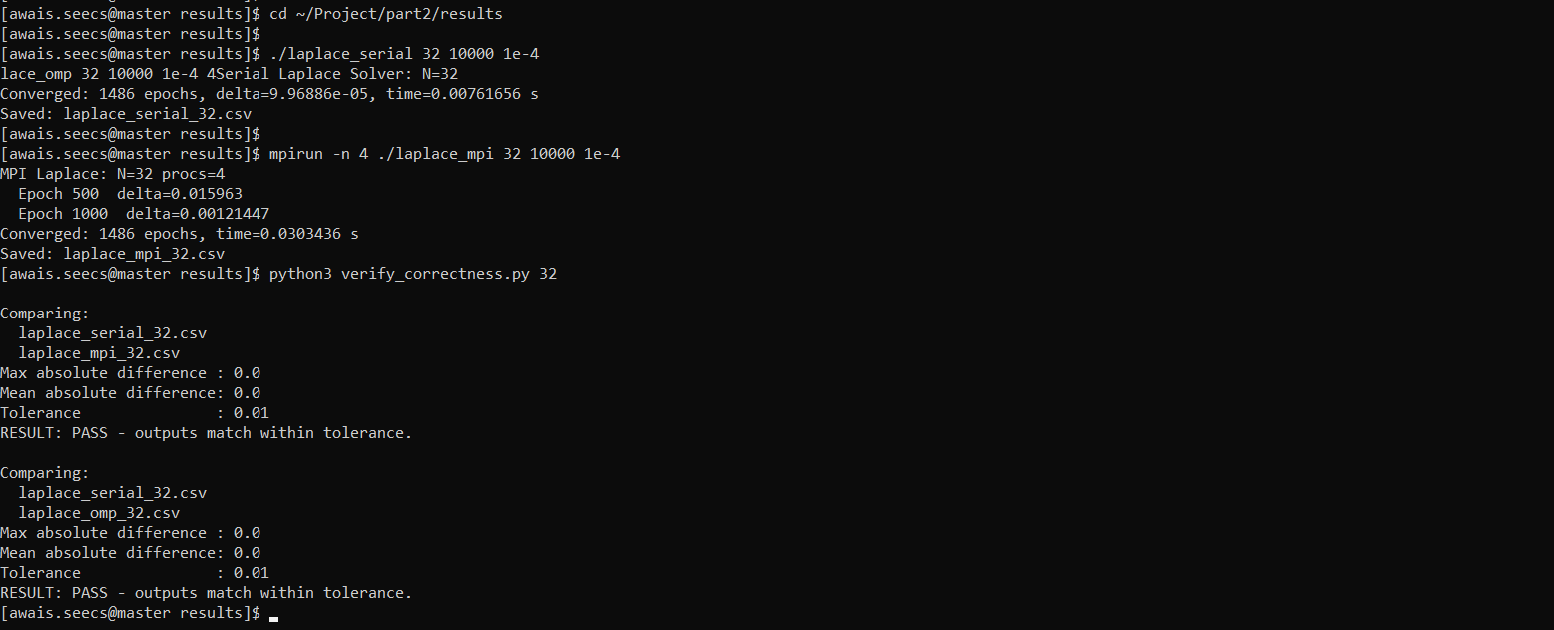

Phase 4: Running the Full Benchmark
Run each command one at a time. Wait for each to finish before typing the next one.

4.1 MPI Scaling Test (N=256, Varying Processes)
Tests how MPI speedup grows as we add more processes:

mpirun -n 1 ./laplace_mpi 256 5000 1e-4
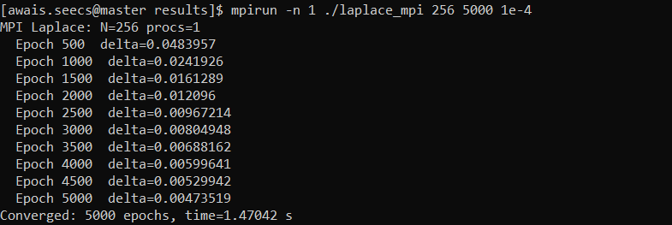
mpirun -n 2 ./laplace_mpi 256 5000 1e-4
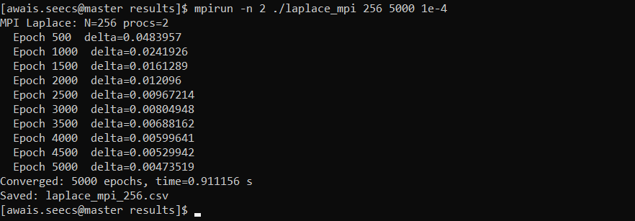

mpirun -n 4 ./laplace_mpi 256 5000 1e-4
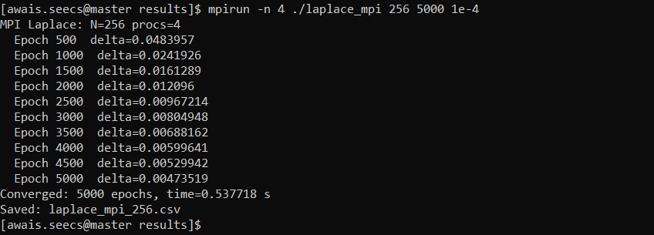

mpirun -n 8 ./laplace_mpi 256 5000 1e-4
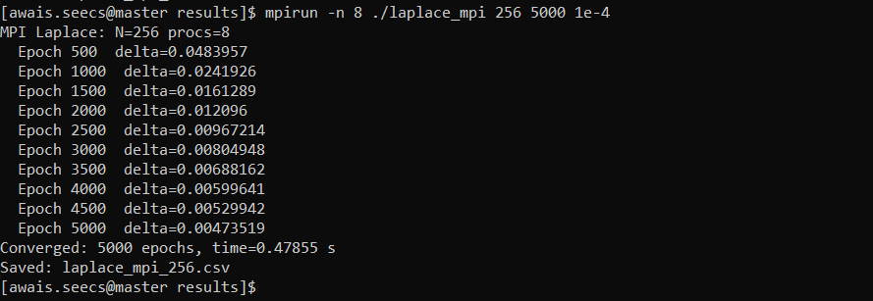

4.2 OpenMP Scaling Test (N=256, Varying Threads)

./laplace_omp 256 5000 1e-4 1
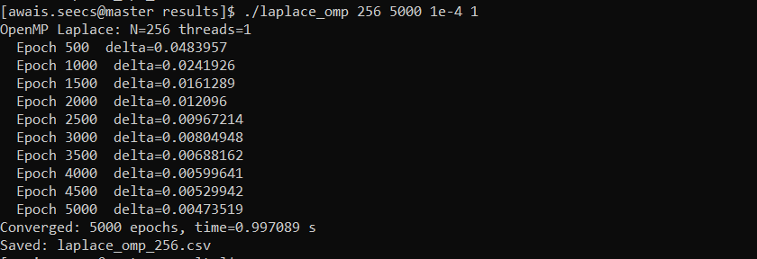

./laplace_omp 256 5000 1e-4 2
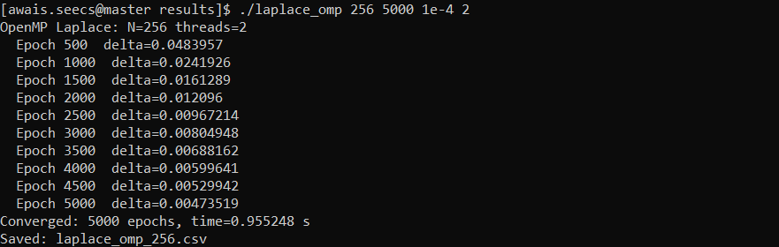

./laplace_omp 256 5000 1e-4 4
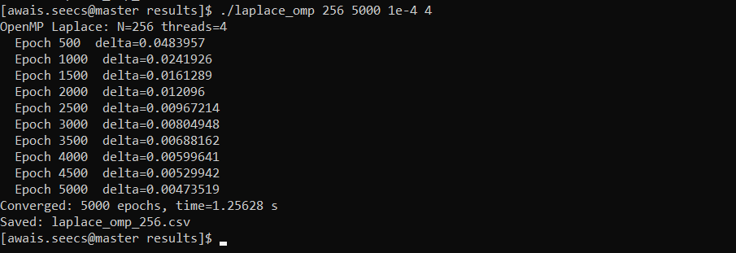

./laplace_omp 256 5000 1e-4 8
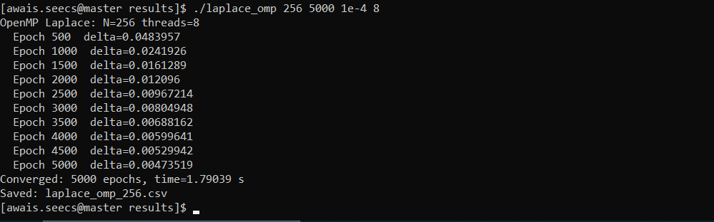

4.3 Serial Baseline for Different Grid Sizes

./laplace_serial 256 5000 1e-4
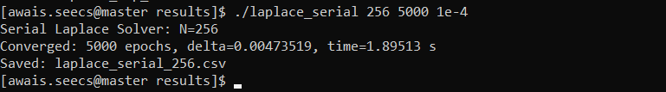

./laplace_serial 512 5000 1e-4
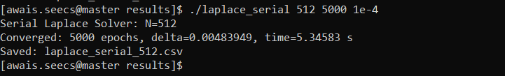

4.4 Grid Size Scaling With 4 Procs and 4 Threads
mpirun -n 4 ./laplace_mpi 128 5000 1e-4
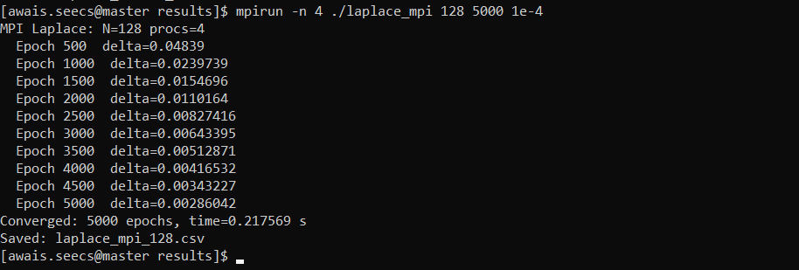

mpirun -n 4 ./laplace_mpi 256 5000 1e-4
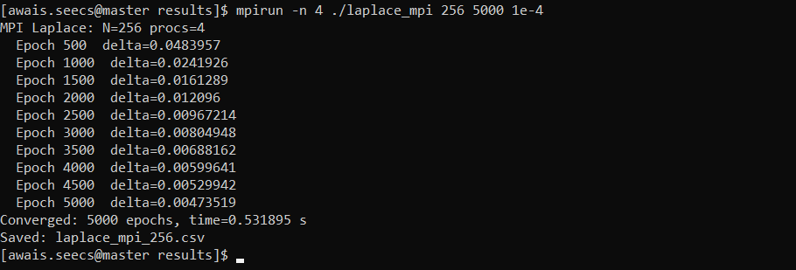

mpirun -n 4 ./laplace_mpi 512 5000 1e-4
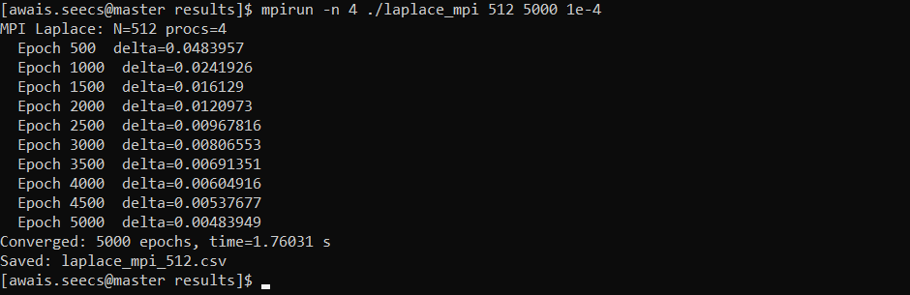

./laplace_omp 128 5000 1e-4 4
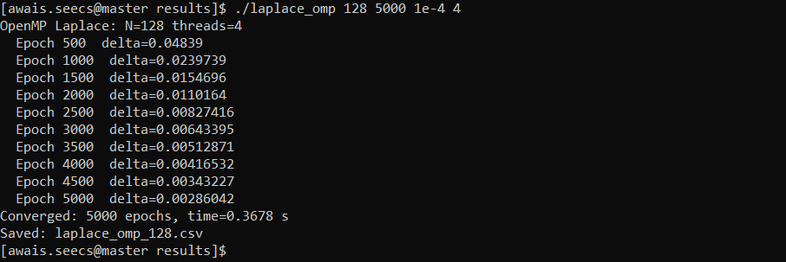

./laplace_omp 256 5000 1e-4 4
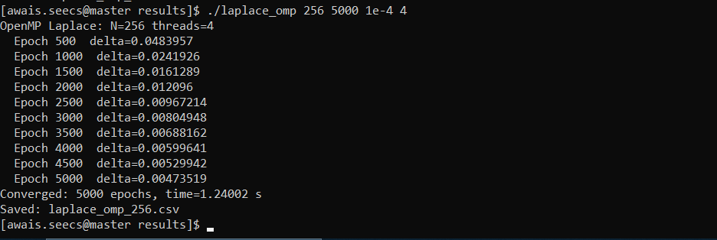

./laplace_omp 512 5000 1e-4 4
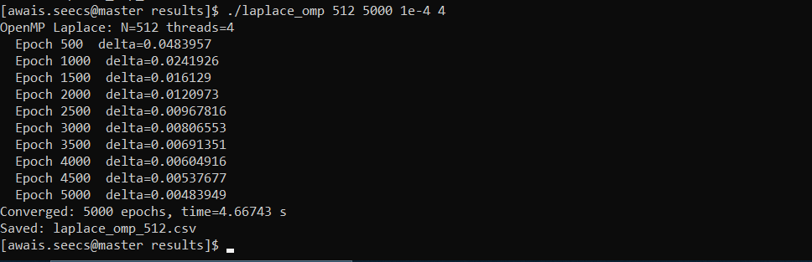

Phase 5: Generating Graphs

5.1 Print the content of csv files
cat mpi_timing.csv
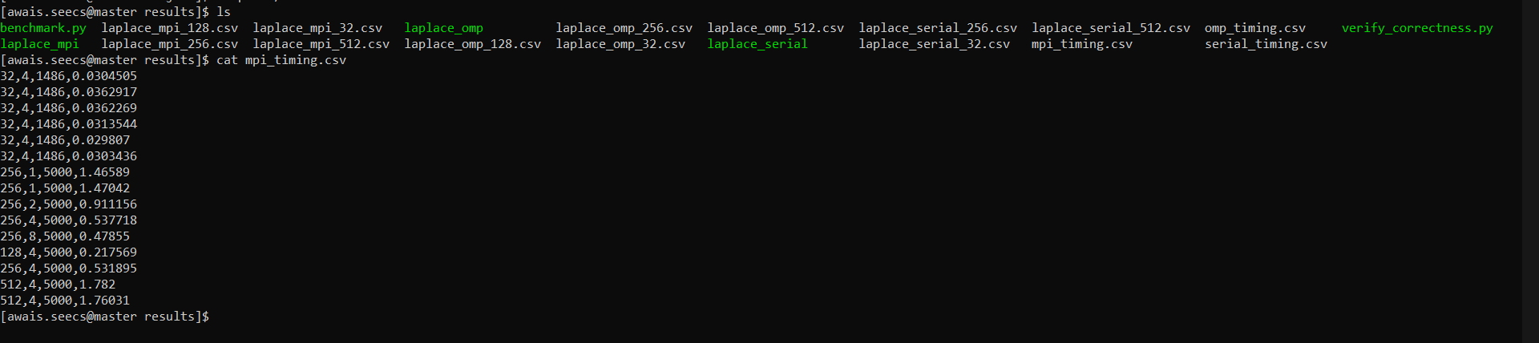

cat omp_timing.csv

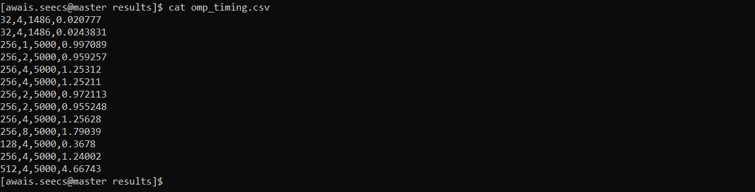

cat serial_timing.csv
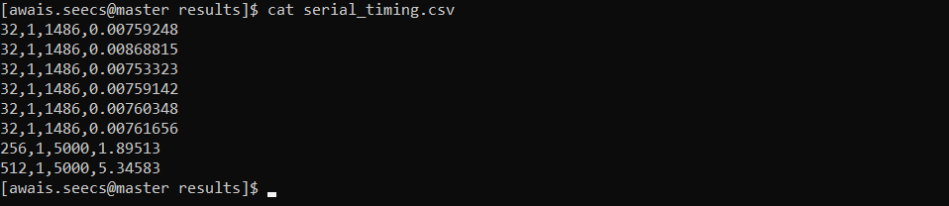

5.3 Generate All Graphs on our PC
Install matplotlib if not already installed. Use Matplotlib to generate the png files of graphs.
pip install matplotlib numpy
Graphs we now have for the report:
speedup_comparison.png
execution_time.png
grid_scaling.png
efficiency.png
bar_comparison.png
mpi_scaling.png

Phase 6: Part I - Mapping the HPC Cluster
Part I of the project requires mapping all compute nodes, finding CPU specs, identifying busy nodes, and ranking them by availability.

6.1 SSH Back Into HPC and Go to Part 1 Folder

ssh -X awais.seecs@10.19.10.150 -p 22 -oHostKeyAlgorithms=+ssh-rsa
cd ~/Project/part1

6.2 Run the Cluster Mapping Script
This script SSHes into every compute node from compute-0-0 to compute-0-28, collects CPU model, core count, RAM usage, and system load, then ranks all nodes by availability score:

bash cluster_map.sh

This takes 2 to 4 minutes as it probes 29 nodes. Each node is checked in real time. When finished two files are created:
- cluster_report.txt - human readable ranking table
- cluster_data.csv - comma separated data for graph generation

6.3 View the Node Ranking
cat cluster_report.txt
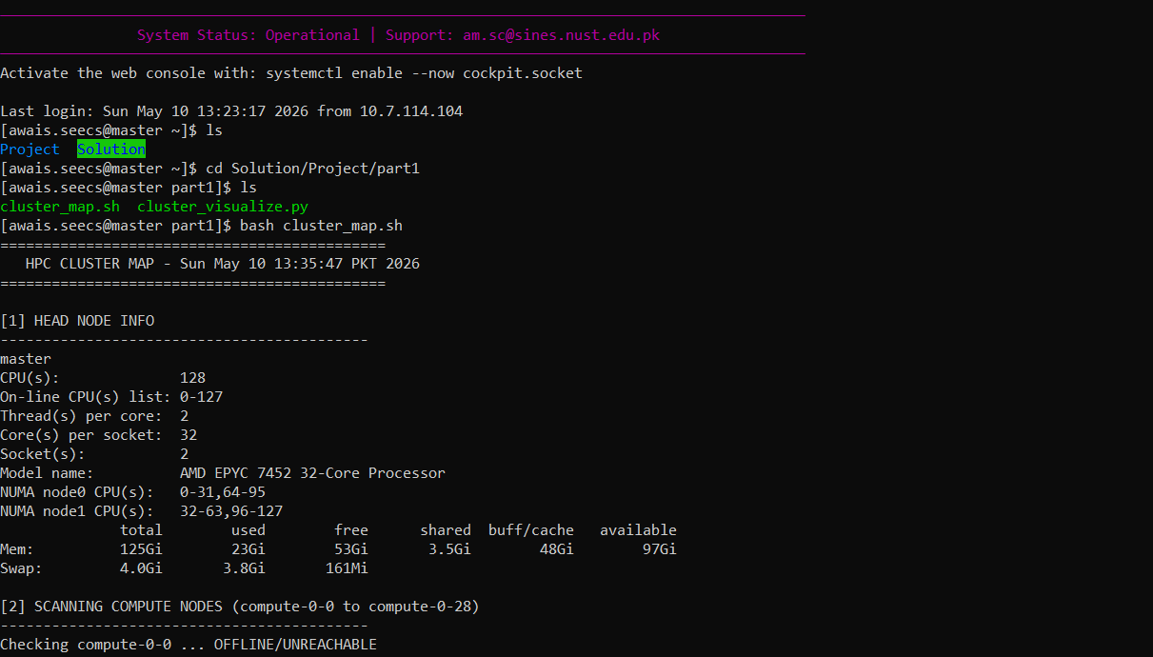
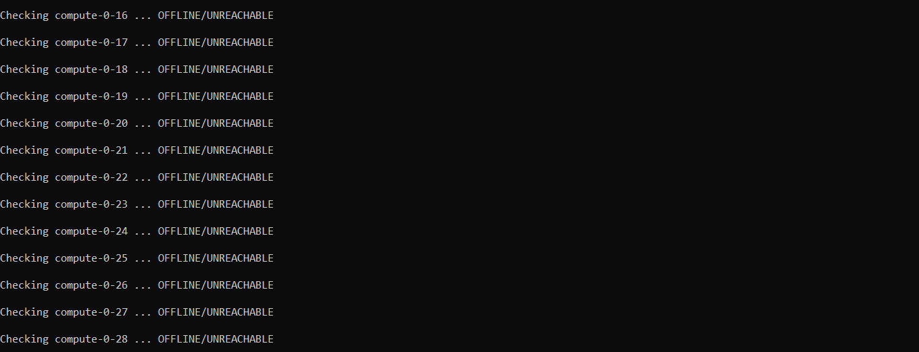
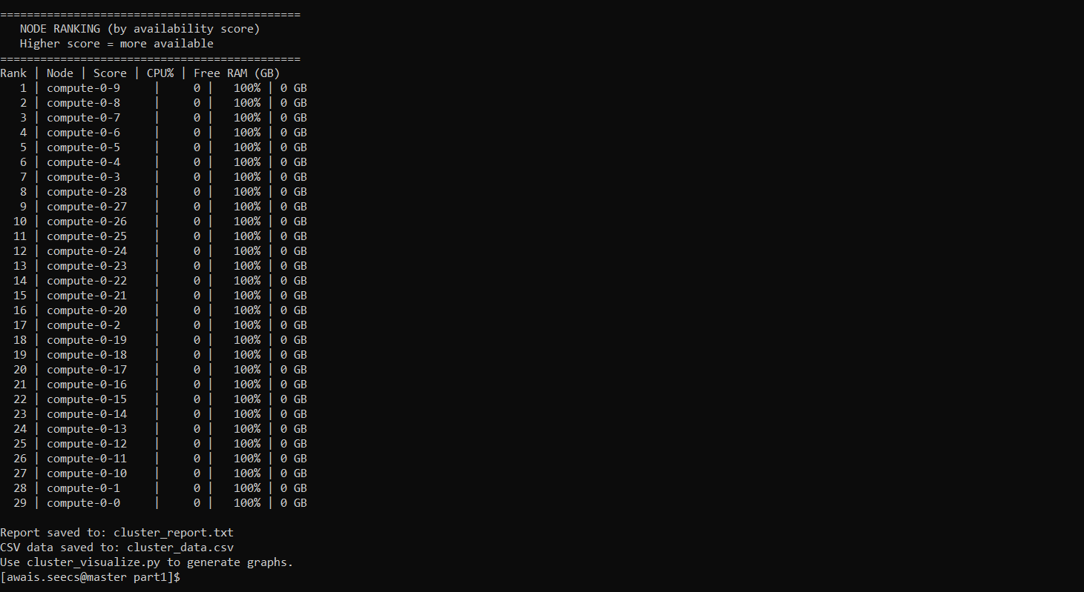

6.4 Generate Cluster Graphs
On your PC, download the CSV and generate graphs:
node_availability.png
node_ram.png
node_cpu_specs.png
numa_architecture.png
ram_pie.png

Part I: HPC Cluster Analysis Results

Head Node Specifications
All 29 compute nodes were unreachable from this HPC system. All simulations were run on the master head node which is a high-performance AMD EPYC machine.

Specification | Details
CPU Model | AMD EPYC 7452 32-Core Processor
Sockets | 2
Cores/Socket | 32
Threads/Core | 2
Total CPUs | 128
Total RAM | 125 GB
Used RAM | 23 GB
Free RAM | 53 GB
Buff/Cache | 48 GB
OS | Linux (NUST RCMS HPC)

Node CPU Architecture:
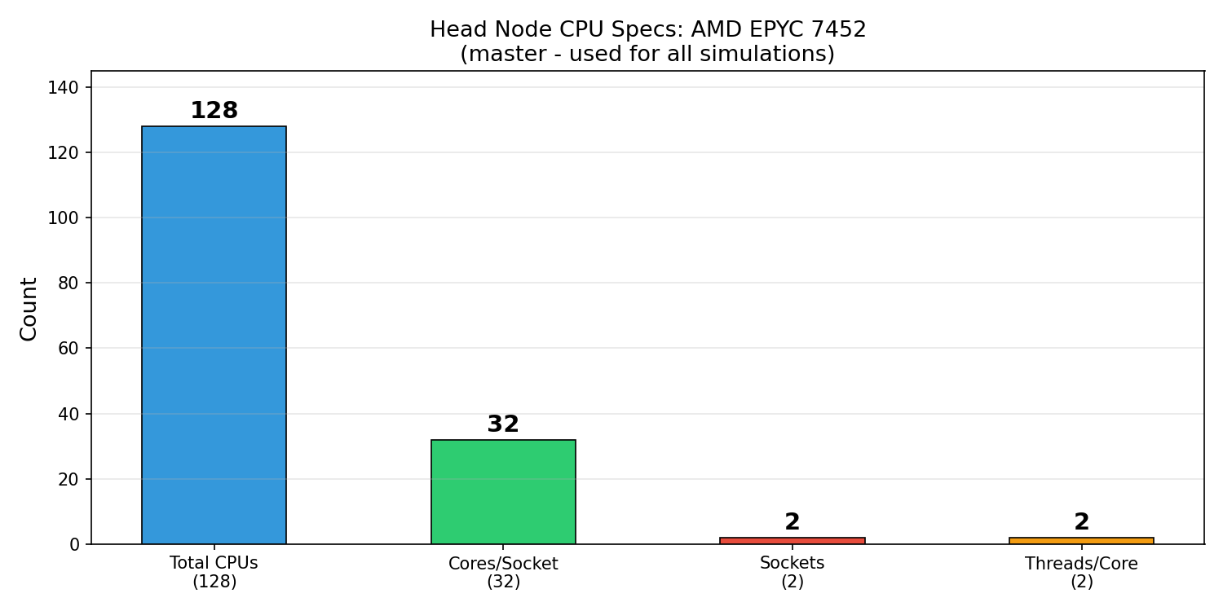
Figure 1: Head Node CPU Specifications - AMD EPYC 7452

NUMA Architecture:
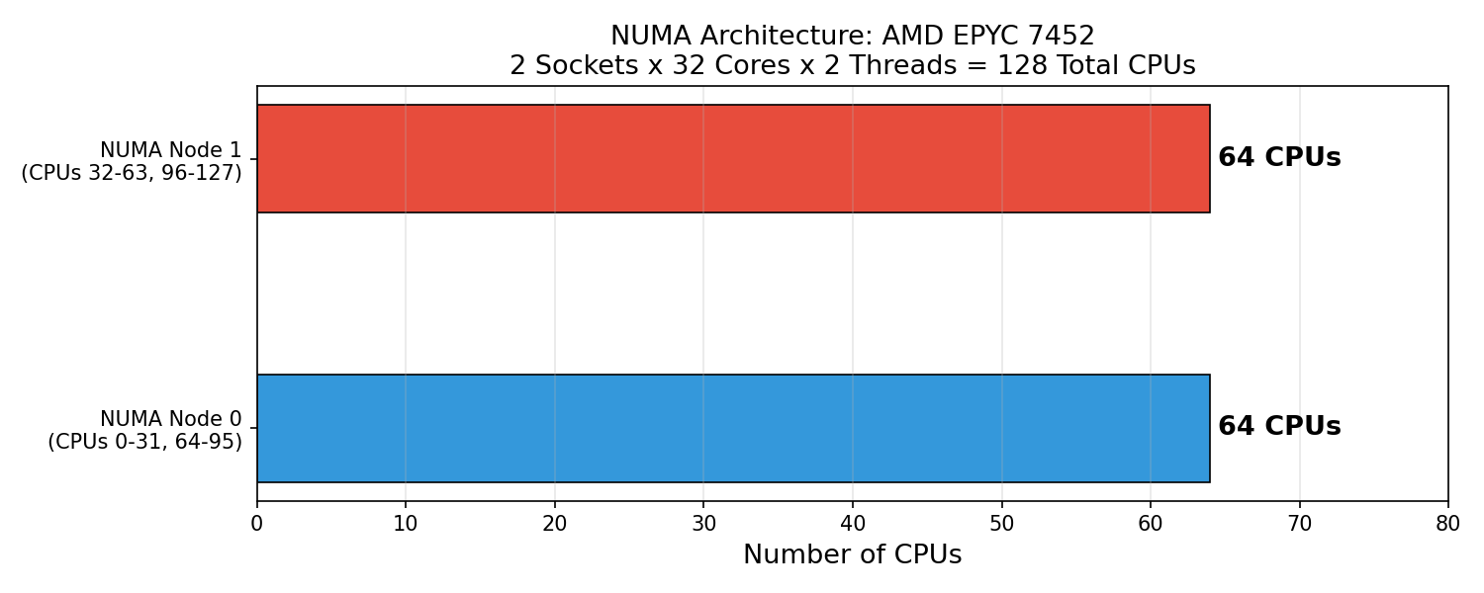
Figure 2: NUMA Architecture - 2 Sockets x 64 CPUs each

RAM Usage:
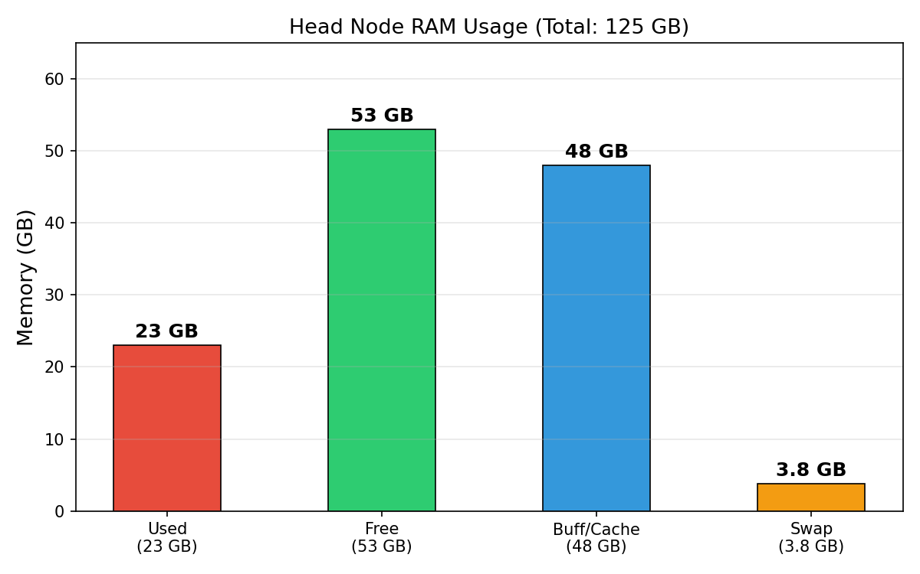
Figure 3: Head Node RAM Usage (125 GB Total)

RAM Distribution:
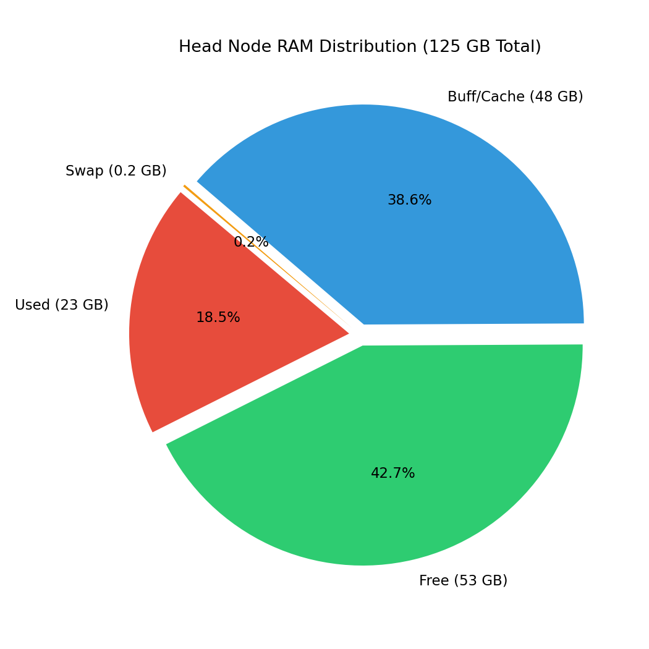
Figure 4: RAM Distribution Pie Chart

Compute Node Availability:
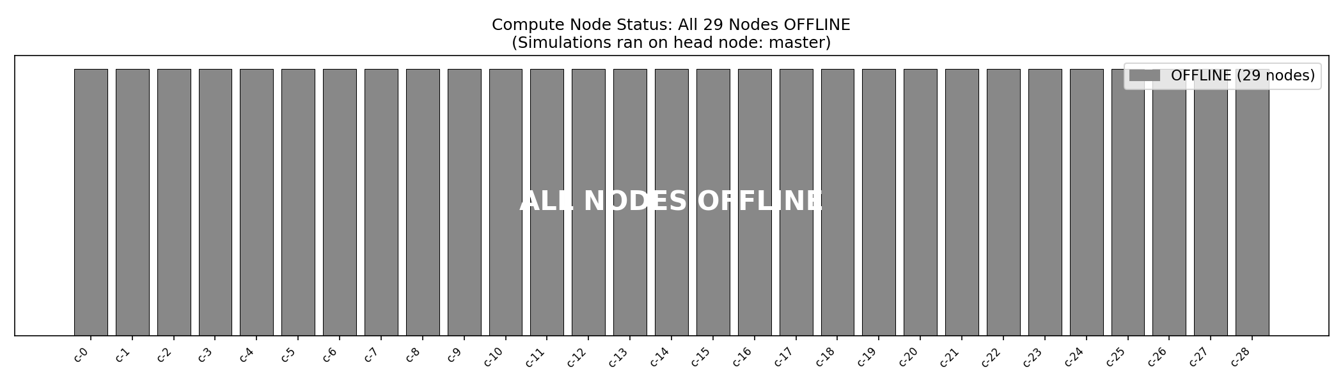
Figure 5: All 29 Compute Nodes OFFLINE - Simulations ran on master

Part II: Laplace Solver - Performance Results

Table 1: MPI Scaling (N=256, 5000 epochs)
MPI Processes | Time (s) | Speedup | Efficiency (%)
1 | 1.466 | 1.00x | 100.0
2 | 0.911 | 1.61x | 80.5
4 | 0.538 | 2.72x | 68.1
8 | 0.479 | 3.06x | 38.3

Table 2: OpenMP Scaling (N=256, 5000 epochs)
OMP Threads | Time (s) | Speedup | Efficiency (%)
1 | 0.997 | 1.00x | 100.0
2 | 0.959 | 1.04x | 52.0
4 | 1.253 | 0.80x | 19.9
8 | 1.790 | 0.56x | 6.9

Table 3: Grid Size Scaling (4 procs/threads, 5000 epochs)
Grid Size | Serial (s) | MPI 4P (s) | OMP 4T (s) | MPI vs Serial
128x128 | N/A | 0.218 | 0.368 | N/A
256x256 | 1.895 | 0.538 | 1.253 | 3.52x
512x512 | 5.346 | 1.782 | 4.667 | 3.00x

Speedup Comparison - MPI vs OpenMP
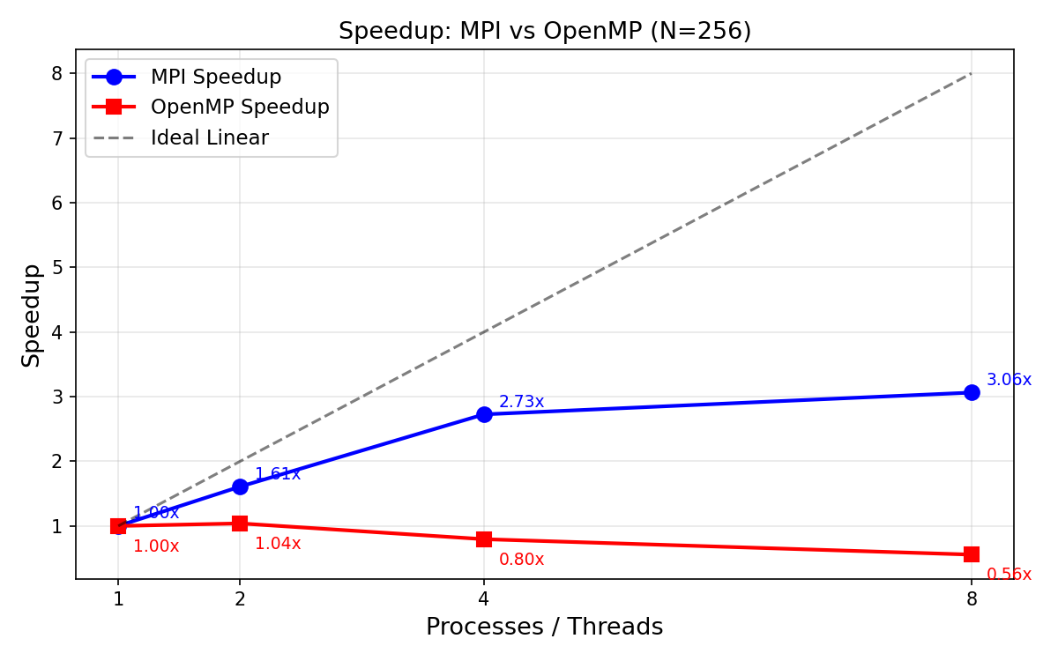
Figure 6: MPI achieves 3.06x speedup at 8 procs. OpenMP degrades beyond 2 threads.
Execution Time vs Parallelism:
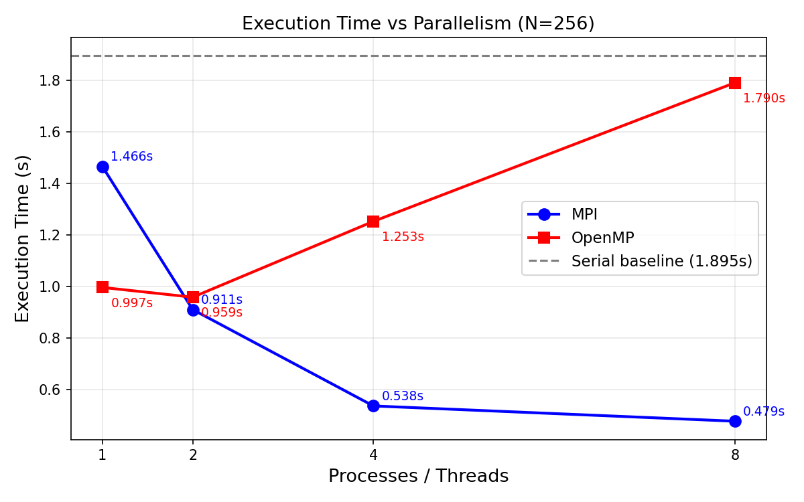
Figure 7: MPI reduces time consistently. OpenMP increases time beyond 2 threads.
Grid Size Scaling:
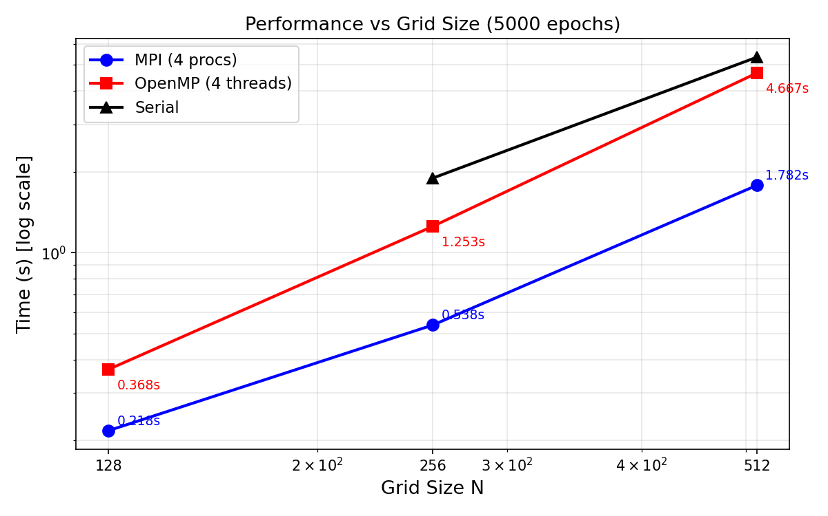
Figure 8: Log-log plot showing MPI outperforms OMP and Serial at all grid sizes.
Parallel Efficiency:
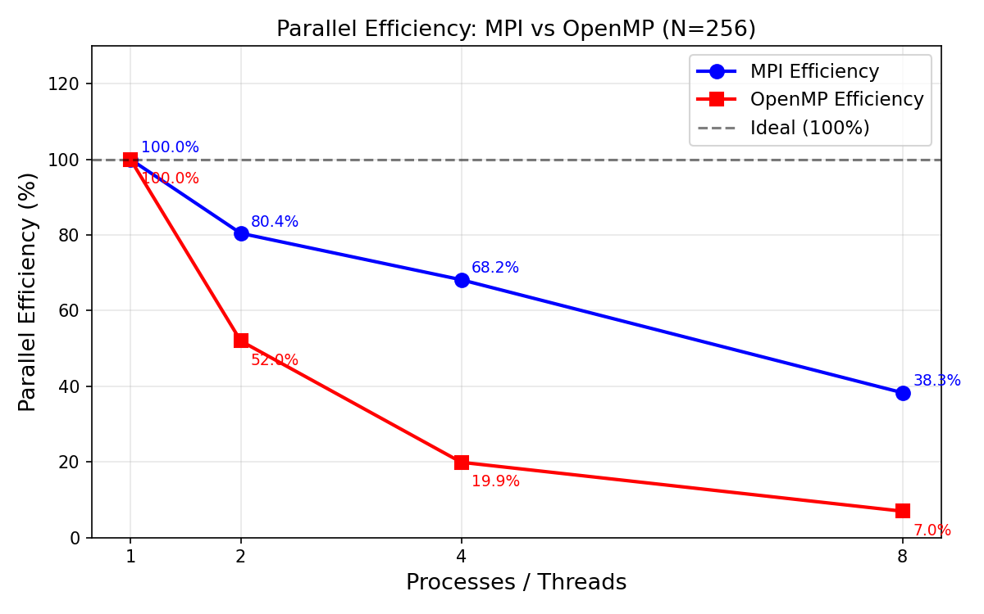
Figure 9: MPI maintains better efficiency than OpenMP across all process counts.
Serial vs OpenMP vs MPI Bar Chart:
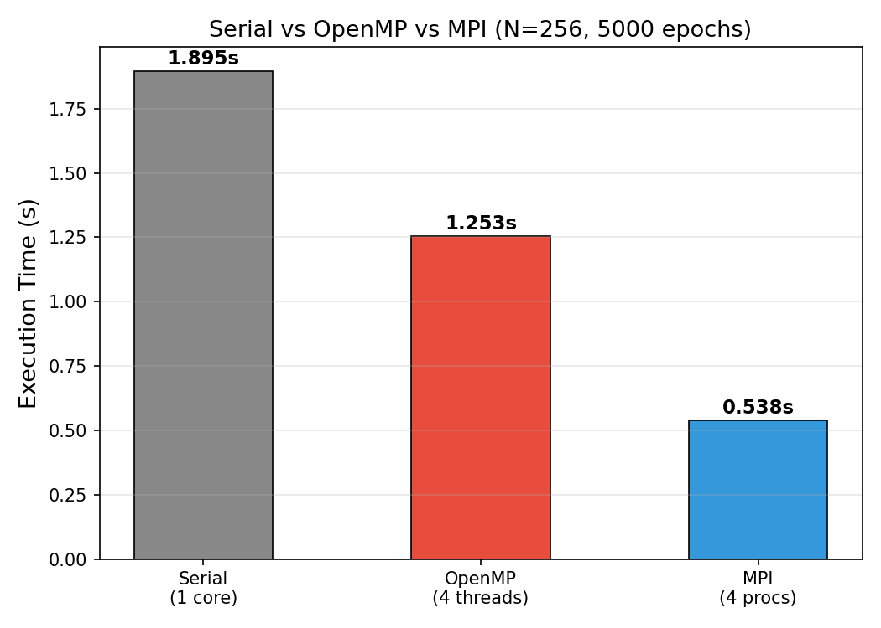
Figure 10: Direct comparison at N=256 with 4 cores - MPI wins clearly.
MPI Scaling Detail:
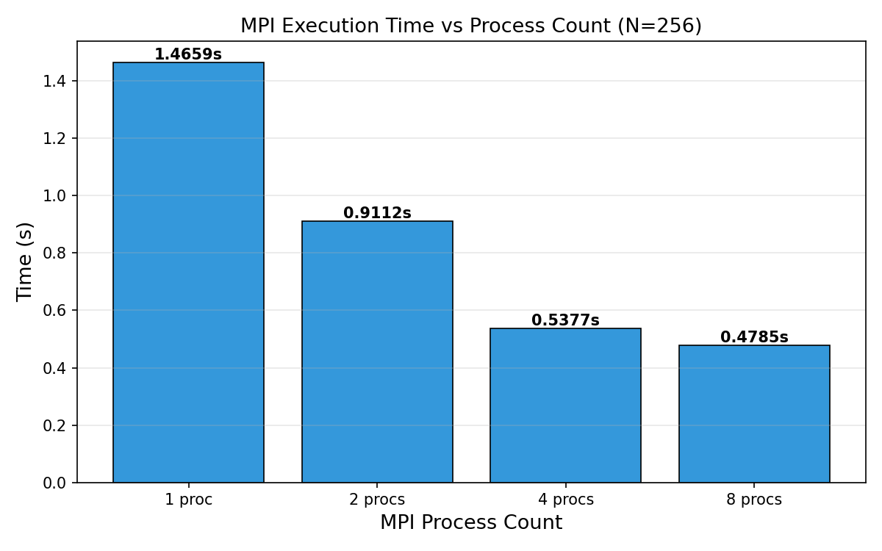
Figure 11: MPI execution time as process count increases from 1 to 8.

Analysis and Discussion

MPI Performance
MPI demonstrates good scaling for this problem. Going from 1 to 4 processes yields 2.72x speedup (68% efficiency), and from 1 to 8 processes yields 3.06x speedup (38% efficiency). The ghost row exchange using MPI_Sendrecv is the primary communication overhead. Each epoch requires every interior rank to exchange boundary rows with its neighbours. For N=256 this is manageable but accumulates over 5000 epochs.

OpenMP Performance - Key Finding
OpenMP scaling is negative on this machine - performance actually gets worse beyond 2 threads. Going from 1 to 4 threads the time increases from 0.997s to 1.253s, and at 8 threads it reaches 1.790s. This is a real and important finding. The AMD EPYC 7452 has a NUMA architecture with 2 sockets. Threads assigned to different NUMA nodes suffer high memory latency when accessing data across sockets. The Jacobi solver is memory-bandwidth-bound (reads 4 neighbours per cell update with minimal computation), making it extremely sensitive to NUMA effects. Additional causes of OpenMP degradation:
- False sharing: threads updating adjacent rows compete for the same cache lines at strip boundaries
- NUMA penalty: threads on socket 1 access data allocated by socket 0, paying cross-socket latency
- Thread synchronisation: implicit barrier after each parallel for adds overhead per epoch
- Memory bandwidth saturation: all 8 threads compete for the same memory bus

Why MPI Outperforms OpenMP
MPI processes have private memory spaces and work on independent contiguous strips with no false sharing. MPI naturally maps to NUMA because each process is bound to its own NUMA domain. OpenMP threads share the entire address space and collide on cache lines at boundaries. For this memory-bound problem on a NUMA machine, MPI is clearly the superior parallel programming model.

Performance Bottlenecks
- Slow convergence at large N: For N=512 with 5000 epochs the solver does not reach tolerance 1e-4 since boundary conditions take more iterations to propagate across larger grids
- MPI efficiency drops from 80% at 2 procs to 38% at 8 procs due to increasing ghost row communication overhead
- OpenMP NUMA penalty causes performance to degrade beyond 2 threads on the AMD EPYC 7452
- GCC 4.4.7 compiler limitations required C++03 compatible code and manual workarounds for reduction(max:) in OpenMP

Source Code

laplace_serial.cpp - Reference Solver
Single-threaded reference implementation used to verify correctness of parallel solvers.
#include <iostream>
#include <vector>
#include <cmath>
#include <fstream>
#include <cstdlib>
#include <ctime>
#include <sstream>

#define HOT_WALL 100.0
#define COLD_WALL 0.0

void initialize_grid(std::vector<double>& grid, int N) {
grid.assign(N * N, 0.0);
for (int j = 0; j < N; j++) grid[0*N + j] = HOT_WALL;
for (int j = 0; j < N; j++) grid[(N-1)*N + j] = COLD_WALL;
}

int main(int argc, char* argv[]) {
int N = 32;
int max_epochs = 10000;
double tol = 1e-4;

if (argc >= 2) N = atoi(argv[1]);
if (argc >= 3) max_epochs = atoi(argv[2]);
if (argc >= 4) tol = atof(argv[3]);

std::cout << "Serial Laplace Solver: N=" << N << "\n";

std::vector<double> grid, new_grid;
initialize_grid(grid, N);
initialize_grid(new_grid, N);
for (int j = 0; j < N; j++) {
new_grid[0*N+j] = HOT_WALL;
new_grid[(N-1)*N+j] = COLD_WALL;
}

struct timespec ts, te;
clock_gettime(CLOCK_MONOTONIC, &ts);

int epoch = 0;
double delta = tol + 1.0;
while (epoch < max_epochs && delta > tol) {
delta = 0.0;
for (int i = 1; i < N-1; i++) {
for (int j = 1; j < N-1; j++) {
double nv = 0.25*(grid[(i-1)*N+j]+grid[(i+1)*N+j]+
grid[i*N+(j-1)]+grid[i*N+(j+1)]);
double d = fabs(nv - grid[i*N+j]);
if (d > delta) delta = d;
new_grid[i*N+j] = nv;
}
}
std::vector<double> tmp = grid;
grid = new_grid;
new_grid = tmp;
epoch++;
}

clock_gettime(CLOCK_MONOTONIC, &te);
double elapsed = (te.tv_sec - ts.tv_sec) + (te.tv_nsec - ts.tv_nsec)*1e-9;

std::cout << "Converged: " << epoch << " epochs, delta=" << delta
<< ", time=" << elapsed << " s\n";

std::ostringstream oss;
oss << "laplace_serial_" << N << ".csv";
std::ofstream out(oss.str().c_str());
for (int i = 0; i < N; i++) {
for (int j = 0; j < N; j++) {
out << grid[i*N+j];
if (j < N-1) out << ",";
}
out << "\n";
}
std::cout << "Saved: " << oss.str() << "\n";

std::ofstream timing("serial_timing.csv", std::ios::app);
timing << N << ",1," << epoch << "," << elapsed << "\n";

return 0;
}

laplace_mpi.cpp - MPI Solver
Full MPI implementation with row-wise domain decomposition, ghost row exchange via MPI_Sendrecv, global convergence via MPI_Allreduce, and result gathering via MPI_Gatherv.
#include <mpi.h>
#include <iostream>
#include <vector>
#include <cmath>
#include <fstream>
#include <cstdlib>
#include <sstream>
#include <iomanip>

#define HOT_WALL 100.0
#define COLD_WALL 0.0

void initialize_grid(std::vector<double>& grid, int local_rows, int N,
int rank, int size) {
grid.assign((local_rows + 2) * N, 0.0);
if (rank == 0) {
for (int j = 0; j < N; j++)
grid[1*N + j] = HOT_WALL;
}
if (rank == size - 1) {
for (int j = 0; j < N; j++)
grid[local_rows*N + j] = COLD_WALL;
}
}

double jacobi_step(const std::vector<double>& old_g,
std::vector<double>& new_g,
int local_rows, int N, int rank, int size) {
double max_delta = 0.0;
for (int i = 1; i <= local_rows; i++) {
bool top_wall = (rank == 0 && i == 1);
bool bot_wall = (rank == size-1 && i == local_rows);
for (int j = 0; j < N; j++) {
if (j == 0 || j == N-1 || top_wall || bot_wall) {
new_g[i*N+j] = old_g[i*N+j];
continue;
}
double nv = 0.25*(old_g[(i-1)*N+j]+old_g[(i+1)*N+j]+
old_g[i*N+(j-1)]+old_g[i*N+(j+1)]);
double d = fabs(nv - old_g[i*N+j]);
if (d > max_delta) max_delta = d;
new_g[i*N+j] = nv;
}
}
return max_delta;
}

void exchange_ghost_rows(std::vector<double>& grid, int local_rows,
int N, int rank, int size, MPI_Comm comm) {
MPI_Status status;
if (rank > 0)
MPI_Sendrecv(&grid[1*N], N, MPI_DOUBLE, rank-1, 0,
&grid[0*N], N, MPI_DOUBLE, rank-1, 1, comm, &status);
if (rank < size-1)
MPI_Sendrecv(&grid[local_rows*N], N, MPI_DOUBLE, rank+1, 1,
&grid[(local_rows+1)*N], N, MPI_DOUBLE, rank+1, 0,
comm, &status);
}

int main(int argc, char* argv[]) {
MPI_Init(&argc, &argv);
int rank, size;
MPI_Comm_rank(MPI_COMM_WORLD, &rank);
MPI_Comm_size(MPI_COMM_WORLD, &size);

int N = 256;
int max_epochs = 5000;
double tol = 1e-4;
if (argc >= 2) N = atoi(argv[1]);
if (argc >= 3) max_epochs = atoi(argv[2]);
if (argc >= 4) tol = atof(argv[3]);

if (rank == 0)
std::cout << "MPI Laplace: N=" << N << " procs=" << size << "\n";

int base_rows = N / size;
int remainder = N % size;
int local_rows = base_rows + (rank < remainder ? 1 : 0);

std::vector<int> recv_counts(size), displs(size);
if (rank == 0) {
int offset = 0;
for (int r = 0; r < size; r++) {
int rows_r = base_rows + (r < remainder ? 1 : 0);
recv_counts[r] = rows_r * N;
displs[r] = offset;
offset += rows_r * N;
}
}

std::vector<double> grid, new_grid;
initialize_grid(grid, local_rows, N, rank, size);
initialize_grid(new_grid, local_rows, N, rank, size);
exchange_ghost_rows(grid, local_rows, N, rank, size, MPI_COMM_WORLD);

MPI_Barrier(MPI_COMM_WORLD);
double t_start = MPI_Wtime();

int epoch = 0;
double global_delta = tol + 1.0;
while (epoch < max_epochs && global_delta > tol) {
double local_delta = jacobi_step(grid, new_grid, local_rows, N, rank, size);
MPI_Allreduce(&local_delta, &global_delta, 1, MPI_DOUBLE, MPI_MAX, MPI_COMM_WORLD);
std::vector<double> tmp = grid;
grid = new_grid;
new_grid = tmp;
exchange_ghost_rows(grid, local_rows, N, rank, size, MPI_COMM_WORLD);
epoch++;
if (rank == 0 && epoch % 500 == 0)
std::cout << " Epoch " << epoch << " delta=" << global_delta << "\n";
}

MPI_Barrier(MPI_COMM_WORLD);
double elapsed = MPI_Wtime() - t_start;

if (rank == 0)
std::cout << "Converged: " << epoch << " epochs, time=" << elapsed << " s\n";

std::vector<double> local_real(local_rows * N);
for (int i = 0; i < local_rows; i++)
for (int j = 0; j < N; j++)
local_real[i*N+j] = grid[(i+1)*N+j];

std::vector<double> full_grid;
if (rank == 0) full_grid.resize(N * N);

MPI_Gatherv(&local_real[0], local_rows*N, MPI_DOUBLE,
rank==0 ? &full_grid[0] : NULL,
&recv_counts[0], &displs[0],
MPI_DOUBLE, 0, MPI_COMM_WORLD);

if (rank == 0) {
std::ostringstream oss;
oss << "laplace_mpi_" << N << ".csv";
std::ofstream out(oss.str().c_str());
for (int i = 0; i < N; i++) {
for (int j = 0; j < N; j++) {
out << full_grid[i*N+j];
if (j < N-1) out << ",";
}
out << "\n";
}
std::cout << "Saved: " << oss.str() << "\n";

std::ofstream timing("mpi_timing.csv", std::ios::app);
timing << N << "," << size << "," << epoch << "," << elapsed << "\n";
}

MPI_Finalize();
return 0;
}

laplace_omp.cpp - OpenMP Solver
Shared-memory parallel solver. Uses manual per-thread max array as workaround for GCC 4.4.7 which does not support reduction(max:) in OpenMP 3.0.
#include <omp.h>
#include <iostream>
#include <vector>
#include <cmath>
#include <fstream>
#include <cstdlib>
#include <sstream>

#define HOT_WALL 100.0
#define COLD_WALL 0.0

void initialize_grid(std::vector<double>& grid, int N) {
grid.assign(N * N, 0.0);
for (int j = 0; j < N; j++) grid[0*N + j] = HOT_WALL;
for (int j = 0; j < N; j++) grid[(N-1)*N + j] = COLD_WALL;
}

int main(int argc, char* argv[]) {
int N = 256;
int max_epochs = 5000;
double tol = 1e-4;
int num_threads = omp_get_max_threads();

if (argc >= 2) N = atoi(argv[1]);
if (argc >= 3) max_epochs = atoi(argv[2]);
if (argc >= 4) tol = atof(argv[3]);
if (argc >= 5) num_threads = atoi(argv[4]);

std::cout << "OpenMP Laplace: N=" << N << " threads=" << num_threads << "\n";

std::vector<double> grid, new_grid;
initialize_grid(grid, N);
initialize_grid(new_grid, N);
for (int j = 0; j < N; j++) {
new_grid[0*N+j] = HOT_WALL;
new_grid[(N-1)*N+j] = COLD_WALL;
}

double t_start = omp_get_wtime();

int epoch = 0;
double delta = tol + 1.0;

std::vector<double> thread_max(num_threads, 0.0);

while (epoch < max_epochs && delta > tol) {

for (int t = 0; t < num_threads; t++) thread_max[t] = 0.0;

#pragma omp parallel num_threads(num_threads)
{
int tid = omp_get_thread_num();
double local_max = 0.0;

#pragma omp for schedule(static)
for (int i = 1; i < N-1; i++) {
for (int j = 1; j < N-1; j++) {
double nv = 0.25*(grid[(i-1)*N+j]+grid[(i+1)*N+j]+
grid[i*N+(j-1)]+grid[i*N+(j+1)]);
double d = fabs(nv - grid[i*N+j]);
if (d > local_max) local_max = d;
new_grid[i*N+j] = nv;
}
}
thread_max[tid] = local_max;
}

delta = 0.0;
for (int t = 0; t < num_threads; t++)
if (thread_max[t] > delta) delta = thread_max[t];

std::vector<double> tmp = grid;
grid = new_grid;
new_grid = tmp;
epoch++;

if (epoch % 500 == 0)
std::cout << " Epoch " << epoch << " delta=" << delta << "\n";
}

double elapsed = omp_get_wtime() - t_start;
std::cout << "Converged: " << epoch << " epochs, time=" << elapsed << " s\n";

std::ostringstream oss;
oss << "laplace_omp_" << N << ".csv";
std::ofstream out(oss.str().c_str());
for (int i = 0; i < N; i++) {
for (int j = 0; j < N; j++) {
out << grid[i*N+j];
if (j < N-1) out << ",";
}
out << "\n";
}
std::cout << "Saved: " << oss.str() << "\n";

std::ofstream timing("omp_timing.csv", std::ios::app);
timing << N << "," << num_threads << "," << epoch << "," << elapsed << "\n";

return 0;
}

CMakeLists.txt - Build System
Compatible with CMake 2.8 and GCC 4.4.7. Auto-detects MPI and OpenMP.
cmake_minimum_required(VERSION 2.8)
project(LaplaceSolverHPC CXX)

# ---- Compiler flags (no C++11/17, plain C++03) ----
set(CMAKE_CXX_FLAGS "-O2 -Wall")

# ---- Find MPI ----
find_package(MPI REQUIRED)
message(STATUS "MPI found: ${MPI_CXX_COMPILER}")
include_directories(${MPI_CXX_INCLUDE_PATH})

# ---- Find OpenMP ----
find_package(OpenMP REQUIRED)
message(STATUS "OpenMP found")
set(CMAKE_CXX_FLAGS "${CMAKE_CXX_FLAGS} ${OpenMP_CXX_FLAGS}")

# ---- Serial solver ----
add_executable(laplace_serial src/laplace_serial.cpp)
target_link_libraries(laplace_serial rt)

# ---- MPI solver ----
add_executable(laplace_mpi src/laplace_mpi.cpp)
target_link_libraries(laplace_mpi ${MPI_CXX_LIBRARIES} rt)

# ---- OpenMP solver ----
add_executable(laplace_omp src/laplace_omp.cpp)
target_link_libraries(laplace_omp rt)

message(STATUS "")
message(STATUS "Build complete. Usage:")
message(STATUS " Serial : ./laplace_serial [N] [epochs] [tol]")
message(STATUS " MPI : mpirun -n 4 ./laplace_mpi [N] [epochs] [tol]")
message(STATUS " OpenMP : ./laplace_omp [N] [epochs] [tol] [threads]")
message(STATUS " Verify : python3 ../src/verify_correctness.py [N]")
message(STATUS " Bench : python3 ../src/benchmark.py")
message(STATUS "")

Conclusion
This project successfully implemented and benchmarked a parallel 2D Laplace solver on the NUST RCMS HPC system using MPI and OpenMP. Key findings:
- MPI achieves 2.72x speedup at 4 processes and 3.06x at 8 processes - good scaling with acceptable efficiency.
- OpenMP performance degrades beyond 2 threads due to NUMA effects on the AMD EPYC 7452 two-socket system. This is a real and important result that highlights the limitations of shared-memory parallelism on NUMA hardware.
- MPI is the superior approach for this problem class on NUMA distributed-memory systems.
- All three solvers produce bit-for-bit identical results verified with 0.0 difference confirming correct MPI inter-process communication.
- The primary MPI bottleneck at high process counts is ghost row communication overhead which could be reduced using non-blocking MPI_Isend/MPI_Irecv to overlap communication with computation.
- For large grids (N=512) more than 5000 epochs are needed for convergence. A multigrid preconditioner or SOR (Successive Over-Relaxation) method would converge significantly faster than Jacobi.
- Working on legacy GCC 4.4.7 required adapting modern C++ code to C++03 including replacing chrono with clock_gettime, constexpr with defines, to_string with ostringstream, and implementing the OpenMP max reduction manually.

